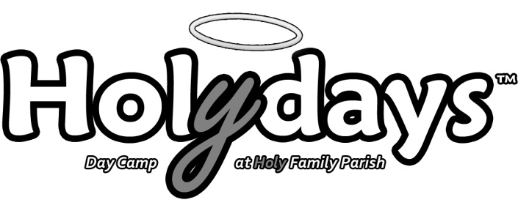
2022 Counselor in Training Application Form

Due by Sunday June 19th, 2022.

Job Summary

We are currently preparing for our eighth summer of Holydays, a day camp program for children in grade 1- grade 6. We are looking for Counselors in Training (CITs) to assist in providing supervision to ensure the physical and emotional safety of our campers. CITs will work with their fellow volunteers and counselors to lead the campers in recreational activities including sports, arts, and skill-based activities. Everyone involved in the day camp will be responsible for preaching the Gospel, living as models of faith, and participating in all faith elements of the camp. Although participation in the CIT Program does not guarantee future employment at the camp, it will certainly be viewed as an asset.

Specific Qualifications

Practicing Catholic

Currently in Grade 8 or older (up to 16 years of age).

Available for a minimum of 2 of the 4 full-week sessions in the summer (this does not guarantee two weeks however).

Able to fully participate in all indoor and outdoor activities.

Complete the Archdiocesan Screening Procedure.

Available to work shifts Monday to Friday, between the hours of 8:00 am to 4:00 pm.

Counselor in Training Information
Full Name: |  |  |  |  |  |  |  |  |  |  |  |  | Date of Birth:
^{Last} |  |  |  |  |  | ^{First} |  |  |  |  |  | ^{M.I.} |  |  | ^{Day/Month/Year}
Address:
^{Street Address} |  |  |  |  |  |  |  |  |  |  |  | ^{Apartment/Unit #}
^{City} |  |  |  |  |  |  |  |  |  |  |  | ^{Prov.} |  | ^{Postal Code}
Phone: |  |  |  |  |  |  | E-mail Address:

General Information
Do you have any past volunteer/ work experiences that would assist you in this position? If so, please explain. ________________________________________________________________________________________________________________________________________________________________________________________________________________________________________________________________________________________________________________________________________________________________________________________________________________________________________________________________________________________________________________________________________________________________________________________________________________________________________________________________________________________________________________________________________________________________________________________________
________________________________________________________________________________________________
What do you hope to gain from this experience?
________________________________________________________________________________________________________________________________________________________________________________________________________________________________________________________________________________________________________________________________________________________________________________________________________________________________________________________________________________________________________________________________________________________________________________________________
________________________________________________________________________________________________________________________________________________________________________________________________
What are you currently doing to nourish your faith life?
________________________________________________________________________________________________________________________________________________________________________________________________________________________________________________________________________________________________________________________________________________________________________________________________________________________________________________________________________________________________________________________________________________________________________________________________
________________________________________________________________________________________________________________________________________________________________________________________________

Availability
Please indicate the weeks you are available. (Minimum 2)
 |  |  | ❑ Week 1: July 4th to July 8th |  |  |  |  |  |  Week 2: July 11th to July 15th
 |  |  |  Week 4: July 18th to July 22nd |  |  |  |  |  |  Week 5: July 25th to July 29th

Special Interests and Skills

Please list any special interests or skill sets you would be able to share at camp (i.e. leading drama activities).
- _______________________  - _______________________  - _______________________ |  |  |  | - _______________________  - _______________________  - _______________________ |  |  |  |  |  |  | - _______________________  - _______________________  - _______________________

References
Please list up to two references who would be able to speak to your personality and work ethic.
Full Name: |  | _______________________________________ |  |  |  |  |  | Relationship: |  | _________________________________________
Phone: |  | __________________________
Full Name: |  | _______________________________________ |  |  |  |  |  | Relationship: |  | _________________________________________
Phone: |  | __________________________

If you have any questions, do not hesitate to contact Eric, Aisling, or Danielle by phone at 905-857-1938 or by e-mail at daycamp@holyfamilybolton.ca.

